CPE 301 – SPRING 2015

DESIGN ASSIGNMENT 6

|  |  |  |  |
| --- | --- | --- | --- |
| **NO** | **SUBMISSION ITEM** | **COMPLETED (Y/N)** | **MARKS**  **(/MAX)** |
| 0. | Flowchart of code | Y |  |
| 1. | Schematics | Y |  |
| 2. | Components connected to the board | Y |  |
| 3. | Screenshot: Gyro Z, Pitch, Roll |  |  |

**0 – Flowchart of code**

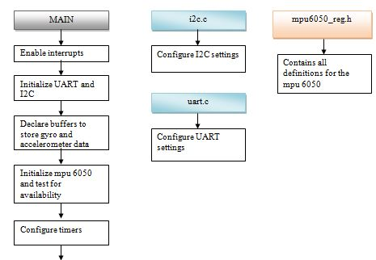

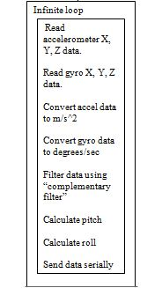

**1 – Schematics:**

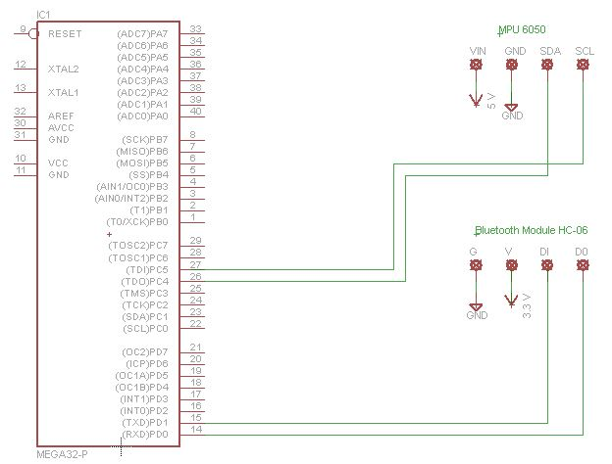

**2 – Components connected to the board**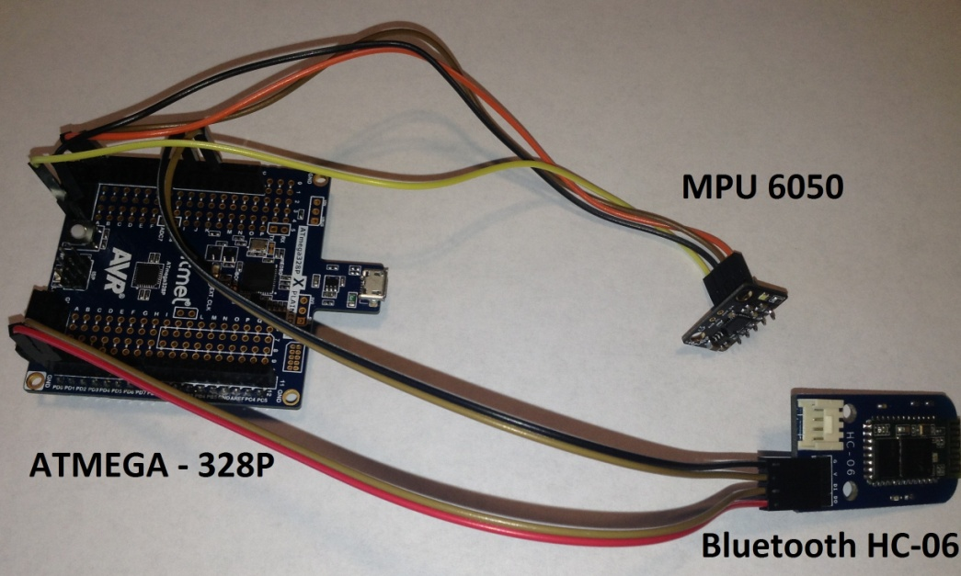

**3 – Screenshot: Gyro Z, Pitch, Roll**

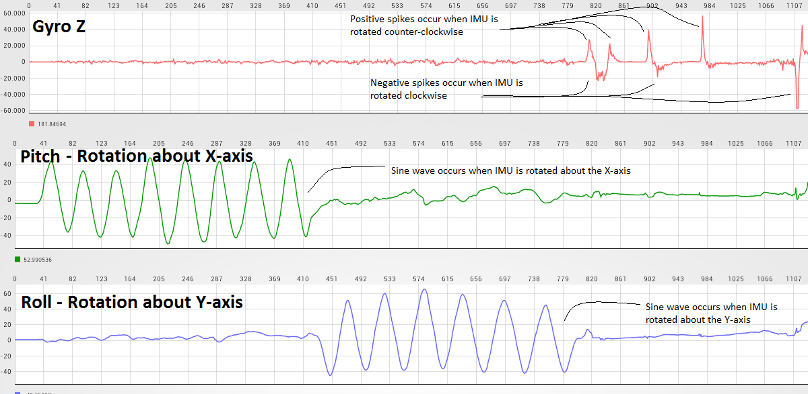

Notes:

* The code was adapted from the sample code found at <https://github.com/YifanJiangPolyU/MPU6050>
* The complementary filter used was found at

<http://www.pieter-jan.com/node/11>

- Emmanuel Sanchez